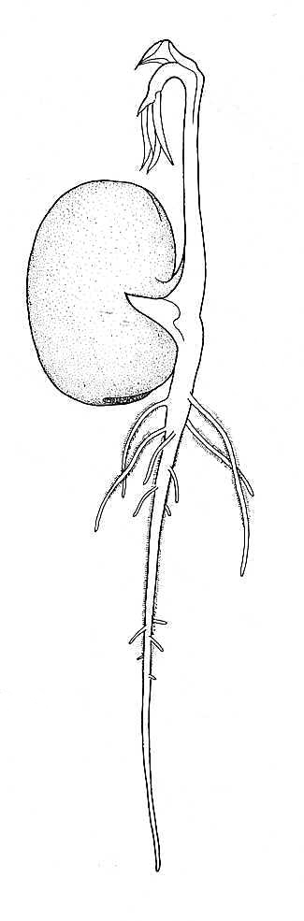

SEED GERMINATION RESEARCH
Name:_______________________

Seeds can lay dormant for a long time (they have been found in
Egyptian tombs) and only start to germinate when they are triggered
to do so.
Research and write:
- What is germination?
- What factors are necessary for seeds to germinate?
- For each factor explain why it is necessary.
- What is the difference between a seed and an embryo? Draw a diagram to show this.
________________________________________________________________________________________________________________________________________________________________________________________________________________________________________________________________________________________________________________________________________________________________________________________________________________________________________________________________________________________________________________________________________________________________________________________
________________________________________________________________________________________________________________________________________________________________________________________________________________________________________________________________________________________________________________________________________________________________________________________________________________________________________________________________________________________________________________________________________________________________________________________
____________________________________________________________________________________________________________________________________________________________________________________________________________________________________________________________________________________________

